Computer Language

Diagram Expression
Expression includes a diagram notation for visualizing the program code. The diagrams are a mere expression of binary interlinked objects. Systematics, stored in a binary way as interlinked objects, are translated to a diagram, expressed on screen. The diagram should be fully automatically drawn out. The metrics and positioning of the shapes and lines is automatically determined. The diagram can be edited, resulting in changes to the stored binary objects.

How each concept is expressed in a diagram is already covered in the documentation of those concepts. The basics of the diagram notation were already covered at the beginning of the new computer language documentation. This documentation folder explains everything else about diagram the diagram notation, such as how the shape positions of the diagram are automatically determined and how the diagram can be colored, to make the systematics even more clear.

The articles in the Diagrams documentation folder are not finished. They consist mostly of texts coming out of an earlier unfinished design of the diagram notation language. The diagram notation has not been realized in software yet.

This folder contains the following articles:

Diagram Metrics

This article is not finished. However, diagram metrics are very important to make the new computer language a success, because if the diagram is not automatically drawn out, and you have to position all the shapes in it yourself, then the language is not that easy to use anymore. The diagrams are automatically drawn out and you get very little say in where the shapes are positioned and how the lines between shapes are drawn out. The interconnection between shapes and the embedding of it, should pull the shapes and lines into the right position like molecules.

Diagrams as a Concept

There is nothing inside this documentation folder yet, but the idea behind diagrams as a concept, is that drawing out diagrams should be implemented as a concept programming construct, which can use the reflective data of objects and translate that to a diagram.

Coloring

There is not a lot of text in this documentation folder yet. This documentation folder is to contain explanations on how the shapes inside the diagram can be colored to highlight certain parts of the system. A system can be fully drawn out with diagrams not using any coloring at all, but coloring may highlight certain parts of the system. You could highlight all objects of a certain class, or you could highlight all classes, or highlight all interfaces, or highlight all objects with classes from a certain site. The possibilities for coloring are endless and you could apply coloring with an infinite possibility of conditions. In the future, a few standard colorings may prove to be particularly handy. All this coloring is for analysis purposes, to highlight certain aspects of a system. You could also just let circles be blue, squares be red, triangles be yellow, diamonds be orange, etcetera. You could just draw the outline of shapes or you could fill the shapes up. Each containment level could get its own color. You could switch between two colors on each deeper containment level. These are all sorts of beautiful possibilities for coloring.

Abusing Diagram Expression

This article is not finished yet. Diagrams are usually drawn out in a standard way: each shape has its meaning, containment has a meaning, lines have a meaning, line types like dashed and dotted have their meaning. The concept of abusing diagram expression is about switching around these means of expression and their actual meanings. For instance: the referential structure of objects is expressed by putting shapes inside other shapes. To express which references inside the diagram point to the same object, lines are used connecting those shapes, that represent the same object. How would the diagram look if you could express the same-object thing with containment and the referential thing with lines between shapes? It is not fully worked out how this would work, but this is what abusing diagram expression should be about: switching means of expression between what they actually express. Another idea, that is also called diagram expression abuse, is to allow shapes to overlap: in the normal diagram notation shapes do not overlap, but abusing diagram expression should also cover how overlap in a system could be expressed in a diagram by actual overlap of shapes.

Abstract Diagram Expression

This article is not finished. Abstract diagram expression means to use the diagram notation leaving all sorts of details out of the diagram, to only draw out the general concept of something. For instance, just drawing two triangles on paper is not a real program yet, but it does mean ‘separation between interfaces’. It is not expressing an actual system, but it is expressing the general concept of something. You can also draw out a diagram, that clearly makes a point about how a system works, while in practice the actual diagram code of the fully working program does not look that way. You could leave out all sorts of details for the sake of making a point. The diagram may even be formally incorrect, but still it makes a point. How you could use the diagram notation as such should be further worked out in this article.

Example Diagrams

This documentation folder contains a zip file with pictures of example diagrams. Some of the diagrams come from analysis of real-life situations, and they are just too inspiring to throw away, so they have been given a place here.

Peels (a rejected concept)

This article is about a concept, that was later rejected. The article contains texts out of an old design of the diagram notation, that are about a notational concept that was later rejected: using extra lines around the shape to reveal information about the target of a line. It should not be gone into too much.

UML

This article is not finished. It should contain an evaluation on what are the pros and cons of the new diagram notation compared to UML: what does UML offer, that the new diagram notation does not and what UML-expressable concepts have a better alternative notation inside the new diagram language? How useful is UML anymore if you have the new diagram notation? Or does UML still offer things, that the new diagram notation does not. And if there is something the new diagram notation does not offer: should the diagram notation be changed, so that UML becomes obsolete? So this article should be a comparison between UML and the diagram notation of the new computer language.

Author & Copyright: Jan-Joost van Zon Date: May 21, 2009 – May 21, 2009 Location: Oosterhout, The Netherlands Status: Finished

Ideas
The texts below are loose ideas, yet to be turned into good documentation.

Diagram Expression concepts:

- Argument Reading, Argument Writing
- Diagram Line Direction
- Diagram Metrics
- System Methods

The diagram does need to be able to display the whole system in terms of just coding principles, and not coding concepts, because you need to be able to start programming coding concepts using the diagrams. The diagrams need to already be in the language, when you don’t yet have coding concepts.
However, coding concepts will be applying to the display of diagrams.

For practical reasons, a triangle's purpose may have to be maintained. This does make the diagram not be an exact representation of ALL the systematics, so that sucks. The different purposes of the triangle may be base class, interface, group, joint access modifier, etcetera. I guess if you want to group members by different aspects, triangles must overlap. I already brainstormed about that some time in the past.
> But overlap can be avoided by automatic containment? Couldn’t it? How would that look? It would create secondary references, won’t it?

Symbol:
The CONNECTIONS between symbols, when 'molecularly' positioned, can form shapes that tell about about the flow of the system. These shapes can become placeholders for the system if the view on it is too small. That way, the connections between symbols form a symbol itself, that stands for the system.

This is nice to put in documentation: that the symbols and their connection, besides being separate connected shapes, when positioned molecularly, will form symbols of their own, consisting of a combination of symbols. When you use standard positioning, these symbols can be interpreted as a whole, instead of looking at each symbol individually.

Show literal values in the symbols at design time, so you can see the result of a calculation immediately.

Not all modeling information is most usefully presented in a graphical notation. Some information is best presented in a textual or tabular format.

Je kunt interfaces toch laten overlappen. Elke drhk die je aanbrengt om te groeperen, creeert meteen een nieuwe interface. Je kunt dus naar een object refereren met als type een groep functies van het ding. Dit creeert meteen een geraffineerde interface onderverdeling in functionaliteit. Omdat dingen in S overzichtelijk blijven, ondanks de vele objecten, is dit alleen maar ok.

Een Public interface zal er zijn, een Private interface base interfaces en dus interfaces per groep. Wat dus wel zo is, is dat een member bij verschillende interfaces kan horen. Eigenlijk creeert dat een member per interface, die doordelegeert naar een hogere member, dus daar zit nog wel een vraagstuk. Bij het omzetten van referentieel naar encapsulatief, maak je ook referenties aan? Nee. Dat een referentie maximaal maar 1 hoger mag zijn klopt niet. Een super-super object kan makkelijk een referentie aanleggen in een sub-sub-object, naar een ander object binnen het super object. De interfaces zijn aparte objecten, dus moet er wel een referentie per interface zijn. Er zou een 'lapmiddeltje' kunnen komen om overlappende interfaces toch mogelijk te maken, door een mechanisme in te bouwen, dat referenties naar een hoger, zelfde symbool als overlapping ziet. In wezen zet je een overlappingsbril op, want de afzonderlijke referenties en target symbool bestaan gewoon wel. Net zoals je eigenlijk een encapsulatiebril op kan zetten, terwijl in wezen de structuur gewoon helemaal referentieel is.

You CAN reduce the variety of things computers are applied for (flows of application of computerprocesses) to a set of standards, such as UML attempts to do. However, I think UML is very incomplete in that area. I would like to integrate diagrams of flows of application of computerprocesses in Symbol and make it integrate into the other kinds of diagram.

Along with very custom views that are the actual applications for for instance playing or manipulating sound files or graphics files.

You'd want a diagram that represents every aspect of a system with processes and schedules and user programs Sy isn't good for that yet.

Perhaps sometimes in Symbol diagrams, only the foreward relation should be shown.
And the backward relation should be implicitly there?
(not all relations are dual, though)

Perhaps the fact that something is a foreward or backward relation should be expressed by direction the way I do that already in symbol. Perhaps the containment structure should be derived looking at the relation direction also, and favor outward pointing? (highly disputable) For sy, you should first be looking at how to express a relational structure in an as simple matter as possible, before looking at how to express the object oriented part, and perhaps use elements to express relational, that were originally reserved for expressing OO. The thing about sy was to have an as simple but as explicit as possible expression of OO, because OO was the most important concept. Then it was important to me that all of the system could be expressed in Sy. But now it turned out relational is the most important concept. And now I have to again look first for the simplest and most explicit way to express relational. A dual relation should be expressed as a single line between two circles, I would say, in that case.

Ik zie allemaal molekuulstructuren,
als ik aan cre denk,
al die objectjes die leven...
in 3D. Maar dat worden natuurlijk symbol diagrams, maar goed.

If you select an item in one symbol diagram, you can have a second symbol diagram next to it, that shows that single selected item in more detail.
You can also have two diagrams that independently show different parts of the system.

Don’t want to consider
Ik zie hier duidelijk dat je uit code niet zo makkelijk de structuur van een programma kunt zien. In S kan dat wel. Met UML ook, maar UML is extra werk om te doen, In S niet.

Weet je wat ook leuk is aan Sinas:
UML is niet zo direct meer nodig, omdat je sowieso nooit met code zit zonder diagram.
(ik merk bij veel projecten op het werk, dat als ik oude code in moet zien. Het eest
moeite kost om de structuur weer te doorgronden. UML geeft meteen de structuur
weer, maar dan moet je dat wel eerst maken. Bij Symbol hoef je het niet apart te maken.
Er zijn wel tools om een code geraamte te creeeren uit UML. Together bijvoorbeeld.
Hmmm...

Refer to the reference target coding concept,
saying that that is the way to make a single symbol
in the diagram represent the actual object,
whereas the others are just seen as references
to the object.
Or put the other way around: to have the actual object only represented by
a single symbol.

Invert means of display of containment and reference
<(So there is no exchangability between containment and a line. I used to think that)>

< Somehow I think you could inverse the picture and replace containment by reference and reference by containment. >

< For that I display the containment to a flat reference structure two levels deep.>
< I replace the references going outward in that, by lines directly connecting the shapes. >

< I take the tree that connects the symbols representing the same object. Instead of direct lines I display the lines as embedded references >
< Then I convert that to a containment structure. >

< Now I somehow have to place the two produced pictures inside eachother. >

< I just don’t know what the use of it is. The concepts of containment and lines between references to the same object are not interchangable: one is about how one object refers to the other, the other is about indicating which are the same objects. >
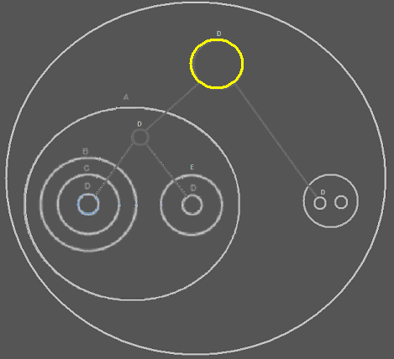

Informal line types:

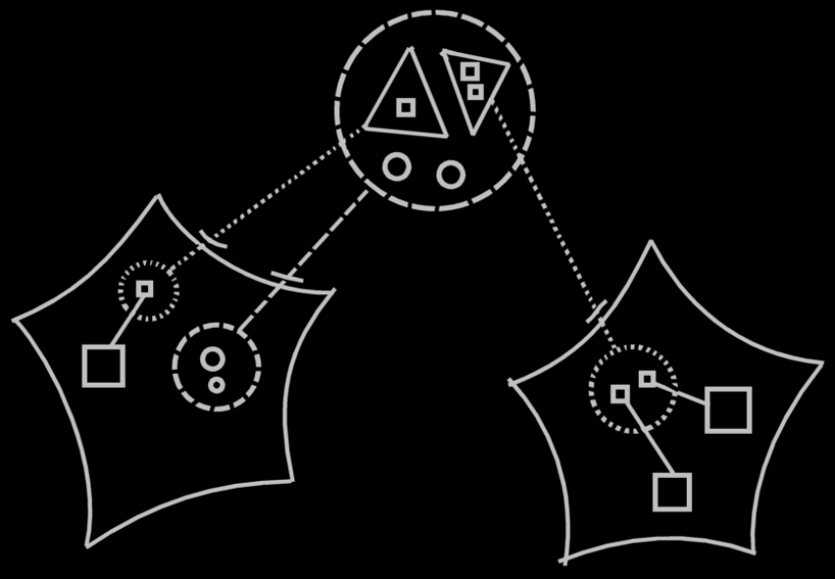

In that picture I also see, that I connect the two method interfaces inside the imaginary class definition to the method interfaces on the separate sites using interface lines. Theoretically that is not right: not only the interface of the symbols connected with an interface line is the same, the definition is the same, so theoretically they should be connected with class lines.
But I made them interface lines just for clarity, because it is all about interface definitions, and now all things about interface definitions are expressed in dotted lines, and all things about class definitions are expressed in dashed lines; it is just clearer this way.
But does this create an ambiguity? The interface line between the interface definition in the imaginary target class and te interface definition on a site, litterly does mean, that only the interface of the two objects is the same: that means: the public contents of them is the same, but the private contents are different, which means the methods have the same interface, but they are different methods, with just the same signature. That’s not what I intended to express, though. The interfaces in the sites should even have been drawn with dotted lines either, because that would imply you are only using it as an interface, while really you’re using it as a definition.

The ‘wrong’ notation is just so much clearer, but it does not formally express the system correctly, because it implies two symbols only have the same interface, but really they have the same definition. But the ‘wrong’ notation of it is just so much clearer. I’m going to have to invent rules that make the ‘wrong’ notation formally ok, or the ‘right’ notation more clear.

J Code Diagrams,

Je kunt ook J Code diagrammen als een 'getilt-te' landkaart weergeven.

JJ

Diagram Expression,

"Your screen doesn't have to do everything. Your brain does the rest."

JJ

Diagram viewer,

Doel van je target symbol in een apart scherm ernaast laten zien /
definitie meteen ernaast.

JJ

Diagram Expression Implementation,
2008-06-10

The diagram expression module can get extended after programming a concept,
that affects the diagram notation. You then get a new version of the diagram
expression module. To show less or more detail in the diagram regarding
basic or advanced concepts, you can might go up and down in version of
the diagram expression module.

JJ

Diagrams, showing definition:
2008-06-10

When you're at a certain object, show the definition of the class at the side of the screen.
You could also choose to display all the definitions of the sub objects.

When you're at a definition, you may opt to show all the sub objects'
system interfaces.

JJ

Diagram Expression,

A special thing about the notation
of definitions (command definitions,
classes, interfaces, command interfaces)
is, that it expresses all the POSSIBILITIES,
to connect objects to eachother.
An OBJECT will only express the current situation
the object might be in.
The difference is visible in, that connections
that are not yet made, ARE displayed as
the possible connections, that can be made.
Only if you for instance type something as a class,
or USE something as a class, the possible
connections are displayed.
Heck, even for objects I would
probably need to display the possible
connections to make with it,
in order to display all the connection points.

JJ

Diagrams,

Diagram metrics is not even present in among my articles,
even though it is basically a fundamental principle, because the system can not be programmed swiftly, if symbols in the diagram are not positioned automatically.

JJ

Diagram Expression,
2008-07-06

There is a difference between an implicit expression and an abstract expression. Abstract expressions are important. What is an abstract expression needs to be defined. It expresses the type of correlation between objects, but for one side of the correlation it is not expressed what it is specifically tied to, just the way it is tied to it.

JJ

Diagram Expression,
2008-07-20

I realized I frequently use the ellipsis symbol, for a placeholder of stuff not displayed in a diagram. Perhaps I should give it a more defined place in the diagram notation in the future.

See the article System Interface Summary in a Diagram.
If you decide to use the ellipsis symbol, you also need something to collapse a part of the structure again.

JJ

Basic diagram elements,
2008-07-27

< 2008-09-02 Part of this story is outdated, but some things are still relevant and nice explainations. >

The line types solid, dashed and dotted are all three to be used for commands after all, because solid can be used to indicate when two are the exact same definition, because a definition is a permanently created command object. Then you always need to use a dashed line when you indicate a call’s command definition. But imaginary references to the same command definition in automatic containment of command definitions, you have to tie the command definition symbols together with solid lines, so that the static parts of the command definition are the same for all references to the same command definition. If you’d use dashed lines between command definition symbols, then the symbols are not the same object, so won’t have the same instance of static parts.

Or the rule must be: a solid line going from a command call to a command definition is actually a class line. A solid line between two command definition symbols is always an object line.

Not creating such a simplified notation, produces more dashed lines, but it does make you more aware of what kind of connection there is between definitions and calls, and it becomes more apparent, that calls are briefly created objects that are destroyed after they’re done, and that definitions are more permanently available. It makes converting an object into a command and back more understandable as well.

JJ

Basic Diagram Elements,
2008-08-02

For each basic diagram element, you have to motivate why this is the most appropriate symbol for it. Why this symbol is chosen. This motivation is often just philosophical of nature. In the articles about a coding concept, that also introduce a basic symbol, you also have to put this motivation.

JJ

Diagrams,
2008-09-09

Rules or guidelines about where to
start when reading a diagram.

JJ

Out of the original Symbol documentation
A possible notation: showing things further away as smaller.

Seeing everything that's directly or indirectly referring to another thing.
Seeing everything that's directly or indirectly referenced by something.

Computers,
20009-01-29

How I visualize computer processing
on bit-level in my head.

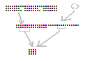

JJ

Diagram Expression,
2009-06-21

Conditional visibility.
Is that abstract diagram expression
or a special form of coloring?

What about coloring that sets the transparency too?

JJ

Diagram Expression,
2009-10-22

In Diagram Expression you can easily see correspondence in 'object'
through lines, rather than through identifier.
Identifiers are the only way in which mutual usage is visible in text code.
That's the big difference.

Any sign of repetition is an invitation for simplification / refactoring.
The key in all of these things is mutual usage and repetition.
The key in the build-up of diagrams is also mutual usage.

JJ

Diagram Expression,
2009-10-22

What if correspondance in value is what you would want to express.
Then the wavy line would stop being an assignment, but start meaning correspondance in value.
That would make things more consistent, and perhaps from a mutuality point of view,
you would decide, that this is the way the language has to be.

JJ

Diagram Expression,
2009-12-08

I think I have already mentioned this idea.
The diagrams for now express value assignments,
but not mutuality of value.
Mutuality of everything else is visible, but mutuality of value is not.

JJ

Taken out of the Interface chapter on 2010-05-07:

Where to start when you read a diagram like this? You first read the containment structure. You start at the largest container, then the smallers ones. After that you look at the relations made by the connecting lines.

You don’t always start with the largest container. Sometimes one symbol is highlighted. Then this symbol is what the diagram is about and it's all about the aspects of this symbol. Then you start at the highlighted symbol and look around. There’s no one way of doing it.

JJ

